**Canadian History of the 21st Century**

**Canada in the 1970s: Quebec Identity**

**ESSENTIAL UNIT QUESTION: *What does Quebec want?***

**Learning Goals:**   
- you will be able to identify biases in individual sources  
- you will be able to make connections between the past and present

- you will analyze and interpret evidence from primary sources

**Success Criteria:**

- you will be able to decide what events and persons reflect significant instances of social conflict and/or inequality in Canada during this period

- you will be describe some significant examples of social and/or political cooperation in Canada during this period

- you will be able to infer ideas from primary sources

**Historical Thinking Concepts and Skills:**

* Use primary source evidence
* Take a historical perspective

**ARTICLES/ARTEFACTS NEEDED:**

* 3 excerpts from Réné Lévesque, Pierre Trudeau, FLQ Manifesto
* Question charts for each article
* Comparison chart for all three articles
* Class set of index cards

**ACTIVATE**

Begin with asking students the big question : *What does Quebec want?* and ask them how they would answer this question with their prior knowledge.

Scaffold the sourcing strategy using the form adapted from Clark, R. and Denos, M. *Teaching about Historical Thinking* (see appendix 1) and do the same about reading strategies (see example of what student should be able to do in appendix 2) for Levesque document. Ask relevant questiosn about the source and circle the words which appear to be deliberate – write margin notes about the tone as you read and ask questions « directly to the text » as if you were talking with it. Model how to respond to those questions by using multiple resources.

**Source 1**

*[…] What is at stake? The right to live one’s life, to live our life; the right of men to live, whether they are weak or powerful; the right of peoples and nations to live, whether they are large or small…We have a country to create, and very little time in which to do it…we are Québécois. What that means first and foremost – and if need be, all that it means – is that we are attached to this one corner of the earth where we can be completely ourselves: this Quebec, the only place where we have the unmistakable feeling that ‘here we can really be at home.’ [...] Until recently in this difficult process of survival we enjoyed the protection of a certain degree of isolation. We lived a relatively sheltered life in a rural society in which a great measure of unanimity reigned and in which poverty set its limits on change and aspiration alike. We are children of that society, in which the habitant, our father or grandfather, was still the key citizen. We are also the heirs to that fantastic adventure – that early America that was almost entirely French. We are, even more intimately, heirs to the group obstinacy which has kept alive that portion of French America we call Québec. All these things lie at the core of this personality of ours. […]*

Rene Levesque’s 1968 essay, *An Option for Quebec,* pp. 8

**ACQUIRE:**

Make them work in small groups and then circulate from team to team to help students :

Split the students into groups of four to examine Pierre Trudeau’s speech on the Official Languages Act. They should proceed the way they’ve been taught during the modeling session. Remind them to make margin notes as they discuss and to answer the text specific questions.

**Source 2**

[…] *In all parts of the country, within both language groups, there are those who call for uniformity. It will be simpler and cheaper, they argue. In the case of the French minority, isolation is prescribed as necessary for survival. We must never underestimate the strength or the durability of these appeals to profound human emotions.*

*Surely these arguments are based on fear, on a narrow view of human nature, and on a defeatist appraisal of our capacity to adapt our society and its institutions to the demands of its citizens. Those who argue for separation, in whatever form, are prisoners of past injustice, blind to the possibilities of the future.*

*We have rejected this view of our country. We believe in two official languages and in a pluralist society not merely as a political necessity but as an enrichment. We want to live in a country in which French Canadians can choose to live among English Canadians and English Canadians can choose to live among French Canadians without abandoning their cultural heritage.*

*Those of us who have some experience of the difficulties and opportunities of this course are conscious of the risk. But if we are convinced that, as a country and as individuals, we must take it. French Canada can survive not by turning in on itself but by reaching out to claim its full share of every aspect of Canadian life. English Canada should not attempt to crush or expect to absorb French Canada. All Canadians should capitalize on the advantages of living in a country which has learned to speak in two great world languages.* […]

**Statement on the introduction of the Official Languages Bill, October 17, 1968**

**by Prime Minister Pierre Elliott Trudeau**

Finally, have the students examine the FLQ document by themselves using the same steps as earlier. They should also use the appendix 3 to compare those point of view.

**Source 3**

[…] *We have had our fill of a federal system that exercises a senseless policy of importation while the low wage-earners in the textile and shoe manufacturing trades, who are the most ill-treated in Quebec, are thrown out into the street for the benefit of a clutch of damned “money-makers” in their Cadillacs; we have had enough of a federal government which classes the Quebec nation among the ethnic minorities of Canada.*

*We have had our fill of hypocrites like Bourassa who rely on Brinks armoured trucks, the living symbol of the foreign occupation of Quebec, to keep the poor “natives” of Quebec in fear of the misery and unemployment in which they are accustomed to living.*

*We have had our fill of the Ottawa representative to Quebec who wants to give our tax money to the Anglophone bosses to “encourage” them to speak French, my dear, to negotiate in French. Repeat after me: “Cheap labor is main d’œuvre à bon marché in French.”* […]

**Selection from the FLQ Manifesto, 1970**

Below are examples of questions students should be able to answer as they then work together to compare the documents and to infer meaning through this process. Provide contextual information about the sources. At this point in the lesson, the teacher may be the source of context or the students can be directed to their textbooks for additional background.

**APPLY:**

Full Class Discussions :

* *Compare the documents as a full class*
* *What are the points of view represented by these sources?*
* *How does this evidence fit within our understanding?*
* *What else do we need to know?*
* *How do the viewpoints conflict?*
* *Is this reflective of a significant event? How would we know? What else do we need to know? Does the addition of background information make these documents more significant?*
* *Based on what students just did, ask them : how do we know about the past? How do we work with evidence?*

Summarize **:** Have students write an exit card answering the question at this point: Based on the three viewpoints, what do they think Quebec wants?

Assess **:** Give constructive and descriptive feedback on exit cards

**Appendix 1**

**Analysing accounts**

|  |  |  |
| --- | --- | --- |
|  | Evidence from source | Inferences/conclusions |
| **Type**  What type of source is this (e.g., interview, article,  diary, speech)? Is the source primary or secondary? |  |  |
| **Origin**  Who produced this source? Who was the intended audience? When and where was it produced? |  |  |
| **Reliability**  How reliable is this source for what you want/need? |  |  |
| **Context**  What was the context (political/social/cultural) at the time this was created? |  |  |
| **Corroboration**  Is the source consistent with other  sources? Which one(s)? |  |  |

|  |  |  |  |
| --- | --- | --- | --- |
| **What questions about the past does this source help us answer?** | **What answers can we infer from this source to answer these questions?** | **What evidence is in this source to support our answer?** | **What does this not tell us? What other evidence do we need?** |
|  |  |  |  |
|  |  |  |  |
|  |  |  |  |

**Appendix 2**

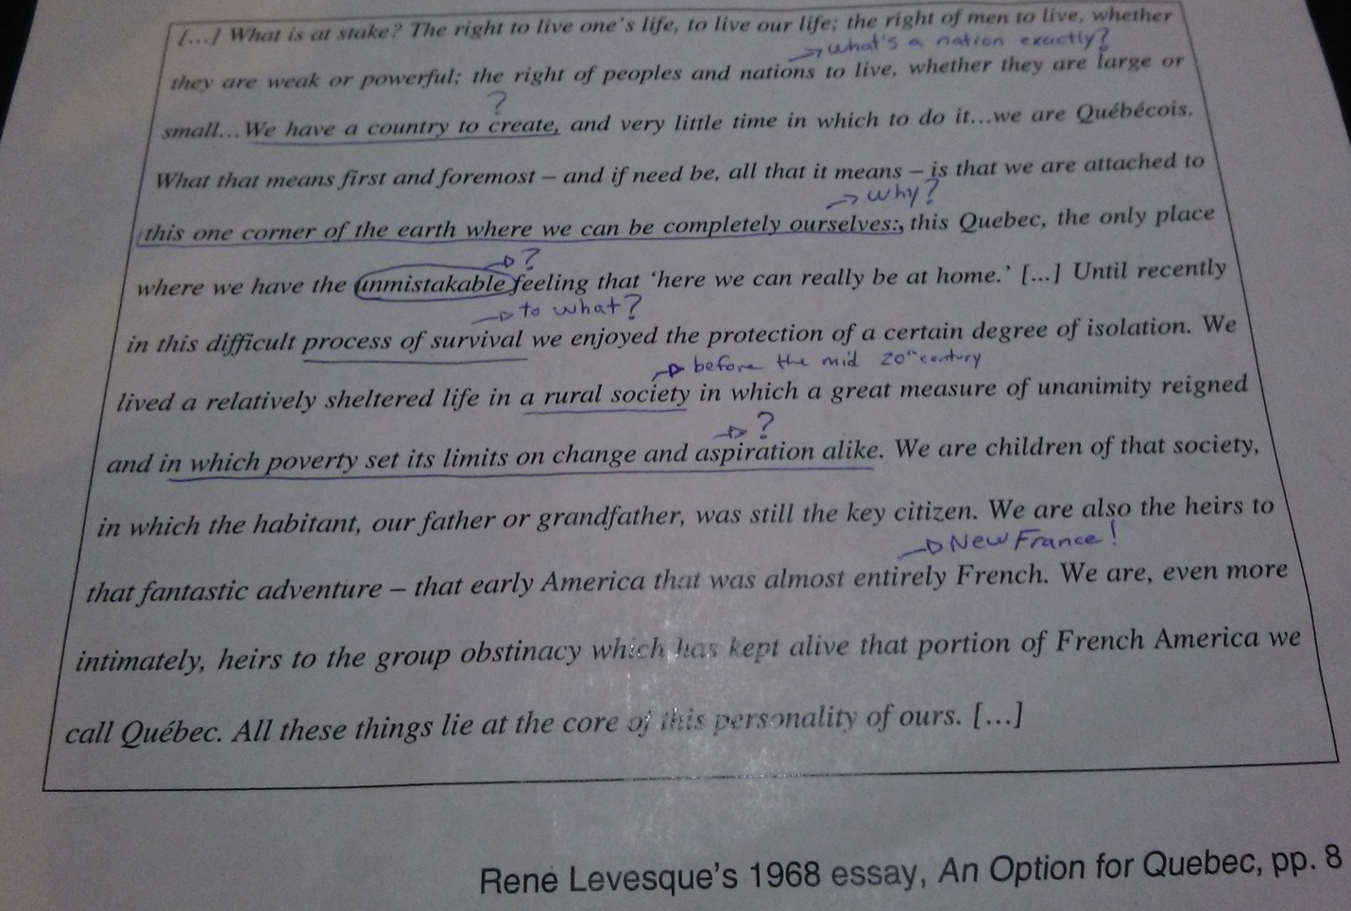

**Appendix 3**

Guiding questions :

*1. What are the viewspoints represented by these sources?*

*2. How do the viewpoints conflict?*

|  |  |  |  |
| --- | --- | --- | --- |
|  | Source 1 | Source 2 | Source 3 |
| Similarities |  |  |  |
| Differences |  |  |  |