Final Report for the Québec Tour of the Anne Frank Exhibition, 2011-2013

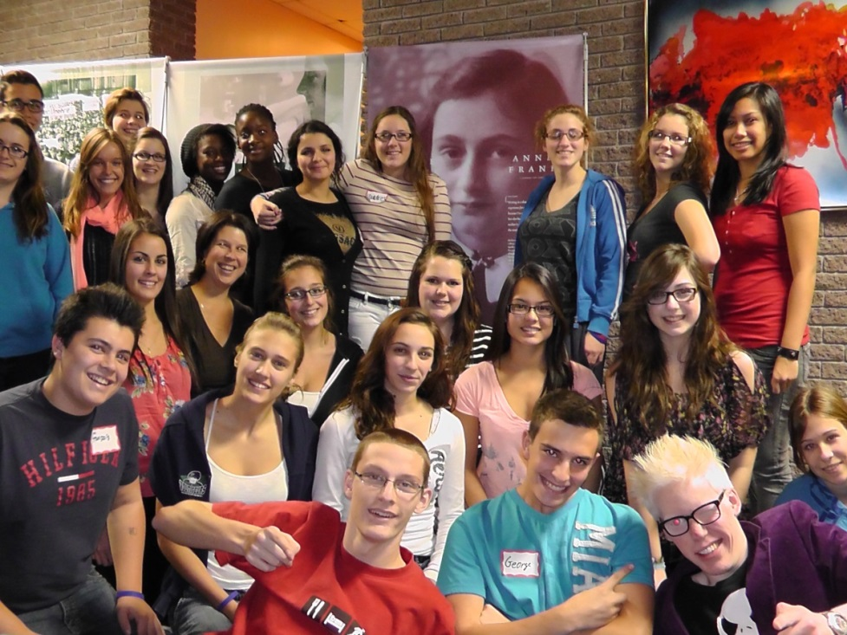
The first trained guides in Rigaud, Québec, November 2011

This project involved a tour in Québec schools of the international travelling exhibition, Anne Frank – A History for Today, created by the Anne Frank House in Amsterdam. This was a two year (2011-2013) pilot project only in Québec. The idea was to see if interest would be expressed in the project in order to take it to the national level for all Canadians. The first year was so successful that the Anne Frank House decided to create a second version to be exhibited in the rest of the country. This report does not include this version which was not envisioned in the pilot project.

The project went much further than simply presenting this exhibition in Québec schools. Students were trained by Anne Frank House personnel (or its partner) and gave the guided tour to other students at their school. The story of this young girl was therefore told by young Québecois to young Québecois. In this way, young Québecois gained knowledge of their country, world history and their own identity. There were several results that can be grouped into two main themes: history and citizenship education.

THEN/HiER’s financial support allowed Anne Frank House to offer educational materials during this project. The grant was used for participant materials in each school location as well as materials for the student guides, such as books, DVDs and the exhibition itself. With this support we were able to transport the exhibition from Amsterdam to Québec so that it could then travel to different locations across the province. The in-province travel was generously funded by our partner in Québec, Veterans Affairs Canada.
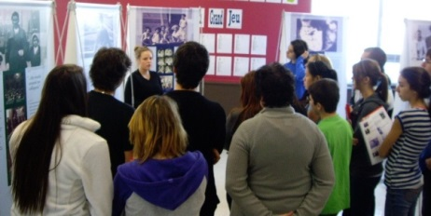
A guide practices during training, Baie-Comeau, January 2012
Historical Theme
The 34-panel exhibition tells the story of Anne Frank and the context in which she lived. Students increased their knowledge of historical events related to WW II and the Shoah (Holocaust). The Anne Frank House worked in close collaboration with Veteran’s Affairs Canada in Québec. Having such a partnership revealed the role played by Canadian troops during WWII. In addition, in almost every school, activities related to the exhibition were organized which highlighted learning about the history of Canada, particularly during WWII. Many of these activities led to in-depth knowledge of one or several historical themes and events in the exhibition.

Efforts were made to make participating students aware of certain aspects of Canada’s history. One was the creation and promotion of a website that details Canada’s history during WWII. The website, http://www.annefrankguide.net/en-CA/default.asp?resetculture=1&showsplash=1, was in the guides’ and teachers’ documents and much reference was made to it. The sections Remember and Canada deal specifically with Canada’s history.

One of the themes on the website deals with immigration laws in Canada in the 1930s and 1940s. The Anne Frank House and its partner would have liked to work more on this website and its various topics. One thing that we particularly wished to do was create a few supplementary panels on Canada’s history and its many interesting and diverse ties to the history of Anne Frank and present them in schools with the Anne Frank House exhibition.

Citizenship Education Theme
The title of the exhibition says a lot about the main goal of the project. The travelling exhibition Anne Frank – A History for Today is meant as a way for young people to learn more about the history of this young girl and to make connections to today. Through the project, the students develop an understanding of why an exhibition about Anne Frank still has importance in 2012-2013. What can this history teach them about themselves? About their society? About the way they communicate with others?

We trained 286 young people to be the official guides for the exhibition whose mission was to provoke discussion within groups who came to see it. It is difficult to evaluate whether these discussions occurred or the level of discussion between students during a tour of the exhibition (the Anne Frank House is aware of this and will look for ways to perform these evaluations in the future). On the other hand, Anne Frank House staff and its partner often saw these discussions taking place initially during the training. Some tours were followed (at times without the guide knowing who the visitors were) and it was noted that the students did make connections to today. Examples were provided of situations of discrimination in the history of Anne Frank and everyday situations in the lives of the Québécois students who encounter similar types of discrimination. The danger of comparing Québec society with the Nazi dictatorial society of the time were of course discussed with the guides during training, but examples were sometimes given so that they would understand the injustice experienced by Jews during WWII.

The main target audience for the project is secondary students (between about 12 and 18 years old). However, several elementary classes that had been moved into secondary schools also toured the exhibition. In addition, in each location where the exhibition was shown it was mandatory to have a daytime or evening public showing of it. In this way the general public was able to have a guided tour of the exhibition.

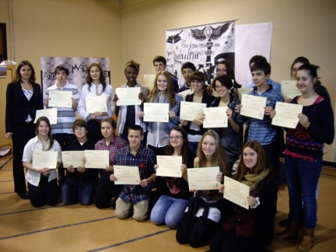
Guides proudly showing their certificate from the Anne Frank House,
Québec, November 2012

Non-exhaustive list of activities organized in conjunction with the exhibition by participating schools:

-torchlight procession signifying a desire for world peace;
-exhibition of works of art by students in relation to the exhibition and its themes;
-written messages of peace on stars for Christmas trees;
-reproduction of Anne Frank’s bedroom (several schools did this);
-messages of peace on coloured banners;
-plaster figurines symbolizing suffering;
-models of Anne Frank’s bedroom;
-messages of peace to post on a paper tree;
-invitation to WWII veterans to tell their stories;
-invitation to Shoah survivors to tell their personal experiences;
-invitation to Anne Frank House staff to give presentations on Anne Frank;
-drawing contest for neighbouring elementary schools;
-reproduction of the revolving bookcase camouflaging the entrance to the hiding space;
-writing exercise for a short comic strip on the history of Anne Frank in English;
-writing exercise of one page of a diary;
-presentation of an exhibition on other genocides (in collaboration with all out of respect for diversity);
-an Amnesty International information kiosk;
-a giant figurine of Anne Frank (art);
-a play on Anne Frank’s story;
-presentation of artifacts on loan from the Montréal Holocaust Memorial Centre (MHMC);
-creation of a questionnaire on Anne Frank’s story;
-creation of a questionnaire on children during wartime (two additional examples);
-an additional exhibition on a child’s testimony during wartime;
-additional short videos of testimonies of other survivors from the Netherlands (loaned by MHMC);
-creation of posters on the contemporary historical period;
-creation and performance of a dance inspired by Anne Frank’s story;
-discussion of themes related to the exhibition such as discrimination, human rights, intimidation and racism;
-written messages of peace forming a photo of Anne Frank;
-re-creation of the railroad leading to Auschwitz;
-giant model of the world made of scraps of paper;
-ceremony of commemoration on Remembrance Day at the school with veterans in attendance;
-invitation for the Consul General of the Netherlands of Montréal to speak during the inauguration;
-writing and presentation of anti-Jewish laws on the blackboard
-creation of posters for the exhibition (each site produced its own poster);
-study trip and visit for young students (and future guides) to the Anne Frank House in Amsterdam;
-reading the text of the play (in French and English)

Here are a few photos of activities held in conjunction with the exhibition:

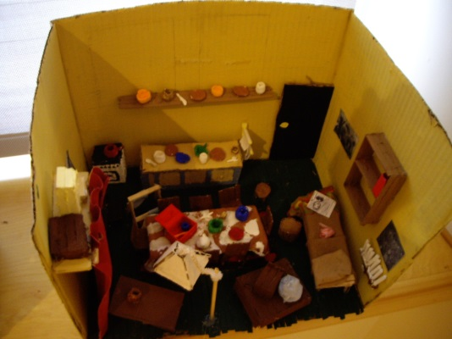
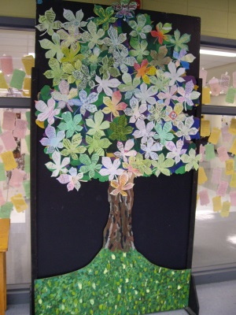
Tree covered in messages of peace and hope, St-Lambert, December 2012

Model of Anne Frank’s room
constructed by a student

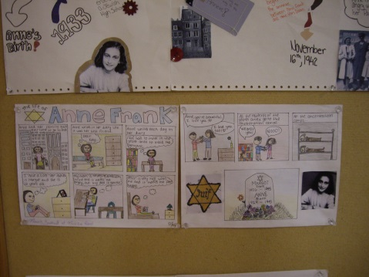

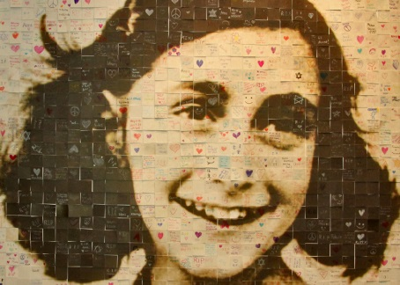
Comic strips created by students, Québec City, October 2012

Re-creation of Anne Frank’s face
with messages of peace,
Montréal, March 2013

Outline of Project
The pilot-project ran for just over two years, from November 11, 2011 to December 31, 2013. Here are the main results of the pilot.

Schools and Other Participating Institutions
Over the course of the pilot-project, the exhibition was presented in twelve secondary schools and four cultural centres (a theatre group, a cultural centre and two museums), located in fourteen cities:
Rigaud, Baie-Comeau, Lévis, Saint-Hyacinthe, Carleton-sur-Mer, Charny, Québec, Saint-Lambert, Lachine, Repentigny, Montréal, Brownsburg-Chatham, Saint-Jean-Port-Joli et Beauceville.

Total Number of Visitors/Trained Students
A total number of 24,330 Canadians visited the exhibition in these sixteen locations, most of whom were accompanied by a trained guide. In all, 286 students, most in their 4th or 5th year of secondary school, took the training for one or two days to become official guides for the Anne Frank exhibition. Following the two-year pilot, we can now state that the peer-guided method was a great success in Québec as well as in other parts of the world where we worked with this method. Every school was enthusiastic by this aspect of the project and all provided their students with the opportunity to be part of this project and become guides on a voluntary basis. We were not sure at the outset how this method would be received in Québec schools, but soon discovered that these schools were just as enthusiastic as others. Each guide received an exhibition catalog and a document that was partially funded by the financial support of THEN/HiER. Thus, the young guides had all the information at hand to adequately prepare for their role.

Table of locations where the exhibition took place 2011-2013
 | Name of institution | City | Day/month/year | # of visitors | # of trained guides
2011
1 | Collège Bourget | Rigaud | 11-11-11 / 11-01-12 | 2200 | 25
2012
2 | École secondaire Jean-Paul II | Baie-Comeau | 23-01-12 / 01-03-12 | 485 | 15
3 | École Marcelle-Mallet | Lévis | 13-03-12 / 13-04-12 | 925 | 11
4 | Collège Saint-Maurice | Saint-Hyacinthe | 16-03-12 / 11-05-12 | 1683 | 38
5 | *Troupe Le Clan Destin, Bureau au Quai des Arts | Carleton-sur-mer | 22-05-12 / 12-06-12 | 750 | 0
6 | (École) les Etchemins | Charny | 22-08-12 / 4-10-12 | 1900 | 8
7 | École secondaire de Neufchâtel | Québec | 8-10-12 / 14-11-12 | 2027 | 21
8 | Collège Durocher-Saint-Lambert | Saint-Lambert | 19-11-12 / 19-12-12 | 2500 | 26
2013
9 | École Sainte-Anne-de-Lachine | Lachine | 16-01-13 / 22-2-13 | 2761 | 38
10 | Centre de formation professionannel (CFP) des Riverains | Repentigny | 01-03-13 / 20-03-13 | 1000 | 15
11 | École Regina Assumpta | Montréal | 25-03-13 / 6-5-13 | 1300 | 19
12 | École secondaire Cavelier-De Lasalle | Montréal | 01-04-13 / 15-05-13 | 1277 | 16
13 | *Société Culturelle Brownsburg | Brownsburg-Chatham | 11-5-13 / 12-6-13 | 858 | 13
14 | *Musée mémoire vivante | St-Jean-Port-Joli | 17-6-13 / 30-10-13 | 2982 | 7
15 | *Musée Régiment de la Chaudière | Lévis | 22-06-13 / 02-09-13 | 982 | 6
16 | Polyvalente Saint-François | Beauceville | 18-11-13 / 13-12-13 | 1600 | 28
total | 12 schools, 4 institutions | 12 cities | 25 months | 24330 | 286

* Other institutions were a theatre group, a cultural centre (which presented the exhibition in a church), and two museums.

Evaluation
Anne Frank House and its partner in Québec (Veterans Affairs Canada) were responsible for transporting and training the guides as well as evaluating their work. For this purpose, an evaluation form was sent to each location where the exhibition was held to obtain comments from schools and other institutions that participated in the project. Therefore we have data on the training and the functioning of the project before and after the presentation, the transport of the exhibition and the experience of the guides. These comments helped us continuously improve our work and the project.

Media attention for the project in Québec (non-exhaustive list):
- Une exposition sur Anne Frank au Québec, TVA Nouvelles, 8 September 2011
- Exposition Anne Frank – Une histoire d’aujourd’hui, le Soleil (Valleyfield), 30 September 2011
- La Maison Anne Frank ne cesse d’émouvoir, Le Soleil, 15 October 2011, Québec
- Anne Frank exhibition to tour schools, The Canadian Jewish news, Montréal, November 10 2011
- La jeune fille au destin tragique, Journal l’Etoile, 15 November 2011
- Anne Frank : l’exposition mondiale à Jean-Paul II, Le Manic, Baie-Comeau, 26 January 2012
- Anne Frank, au cœur d’un projet emballant, Journal mobiles, Saint-Hyacinthe, 6 March 2012
- Le ministre Steven Blaney visite l’exposition « Anne Frank, une histoire d’aujourd’hui » à l’École Marcelle-Malet, Anciens Combattants Canada nouvelles, Lévis, 16 March 2012
- Anne Frank – une exposition présentée à Lévis (Québec), Le passeur de la côte, Lévis, 20 March 2012
- Anne Frank de passage à Saint-Hyacinthe, l’Œil, 7 April 2012
- Anne Frank revivra à Carleton-sur-Mer, Journal L’Avantage, 12 May 2012
- Dans les pas d’Anne Frank, icilévis.com, Lévis, 2 October 2012
- Neufchâtel accueille l’exposition Anne Frank, une histoire d’aujourd’hui, L’actuel, Québec, 10 October 2012
- L’exposition bouleversante d’Anne Frank, une histoire d’aujourd’hui, Le Journal de Montréal, Montréal, 6 November 2012
- Anne Frank et moi, Rive-Sud Express, 22 November 2012
- Se souvenir d’Anne Frank au Collège Durocher Saint-Lambert, media Sud, 22 November 2012
- Le Collège Durocher accueille une exposition consacrée à Anne Frank, Le Courrier du Sud, Saint-Lambert, 4 December 2012
- Une exposition de la Maison d’Anne Frank est de passage à Montréal, Le Devoir, Montréal, 17 January 2013
- Pour mieux connaître l’histoire d’Anne Frank, L’Écho de Repentigny, Repentigny, 20 March 2013
- L’exposition Anne Frank à cushing, Le Journal de Cornwall, Brownsburg-Chatham, 8 May 2013
- Reportage sur point de presse, TV d’Argenteuil, http://tvcargenteuil.com/2013/05/08/lexposition-de-anne-frank-a-brownsburg-chatham/
- Le musée de la Mémoire Vivante inaugure l’exposition Anne Frank, Le Placoteux, St-Jean-Port-Joli, 19 June 2013
- Le Musée du Régiment de la Chaudière accueille l’exposition Anne Frank, le Peuple, Lévis, 6 July 2013
- L'holocauste revisité, Édition Beauce, 8 November 2013
- La Polyvalente Saint-François reçoit Anne Frank, L’éclaireur Progrès, Beauceville, 11 November 2013
- Témoignage sur l’exposition Anne Frank, http://www.youtube.com/watch?v=3WlN_SGlVfU

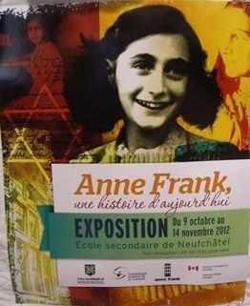
Next Steps
The pilot-project was a real success. Thus, Anne Frank House decided in November 2012 (one year after the start of the pilot) to create an English version of the exhibition for other parts of Canada. The English version was presented in Ontario (Toronto), and British Columbia (Vancouver). It will be presented elsewhere in 2014, including Yukon. The Québec pilot-project has therefore become a Canadian project.

Poster created by a school in Québec City, November 2012

Conclusion
The pilot-project is a testament to the growth of the project in Canada today. The exhibition has had a tremendous impact in schools and communities and has allowed students to develop several skills. The number of visitors demonstrates that Québec society as a whole showed a great interest in the project.

THEN/HiER’s financial support was essential to allow the project to develop into its current form. Without this support at the beginning of the project it would have been difficult (if not impossible) to offer the necessary educational materials to schools and student guides to adequately prepare for their role and to learn more about this unique project. In addition, this support allowed us to cover transportation costs to send the exhibition from Europe to Québec. The entire project therefore depended upon this support. We are very grateful to THEN/HiER for their participation in the project. Thank you for believing in it from the beginning.

Bringing the exhibition to a national level is thus one more step towards completion of the project, when all Canadians can discuss important themes for a democratic and free society. The level of increased awareness about the history of Canada during these difficult years remain something that we would like to investigate over the next few years of the project. The website produced by Anne Frank House already allows people to learn more about their country. We need to explore this in more depth to realize our mission of increasing Canadians’ knowledge of their history.

Report written in February 2014 by Julie Couture, Coordinator of Canadian Projects, Anne Frank House, Amsterdam

